

**School of Computer Science and Engineering**

**CZ3005 - Artificial Intelligence**

Lab 1

Done By:

|  |  |
| --- | --- |
| Ching Jia Chin | U1620237E |

Exercise 1.

1. AppyCompetitor(SumSum)

OwnerOf(SumSum, Gal-S3)

SmartPhoneTech(Gal-S3)

Stole(Stevey, Gal-S3)

Boss(Stevey)

Boss & !Stole(Boss, Business) & OwnerOf(Rival, Business) -> Ethical(Boss)

AppyCompetitor(SumSum) -> Rival(SumSum)

Business(SmartPhoneTech)

1. /* Declarations*/

appyCompetitor(sumsum).

ownerof(sumsum, gal-s3).

smartphonetech(gal-s3).

stole(stevey, gal-s3).

boss(stevey).

business(smartphonetech).

/* functions */

rival(X) :- appyCompetitor(X).

ethical(X):-

boss(X),

ownerof(Owner, Business),

rival(Owner),

\+ stole(X, Business).

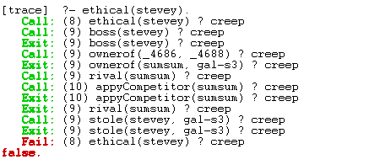

Exercise 2.

1. /* Declarations*/

offsprings([charles, ann, andrew , edward]). /* Declared according to order of birth*/

male(charles).

male(andrew).

male(edward).

female(ann).

/*sort function for old succession*/

mysort([], [], []).

mysort([H|T], MS, FS):-

mysort(T, MS0, FS),

male(H),

append([H], MS0, MS);

mysort(T, MS, FS0),

female(H),

append([H], FS0, FS).

/*Main Succession call function*/

succession(X) :-

offsprings(L),

mysort(L, M, F),

append(M, F, X).

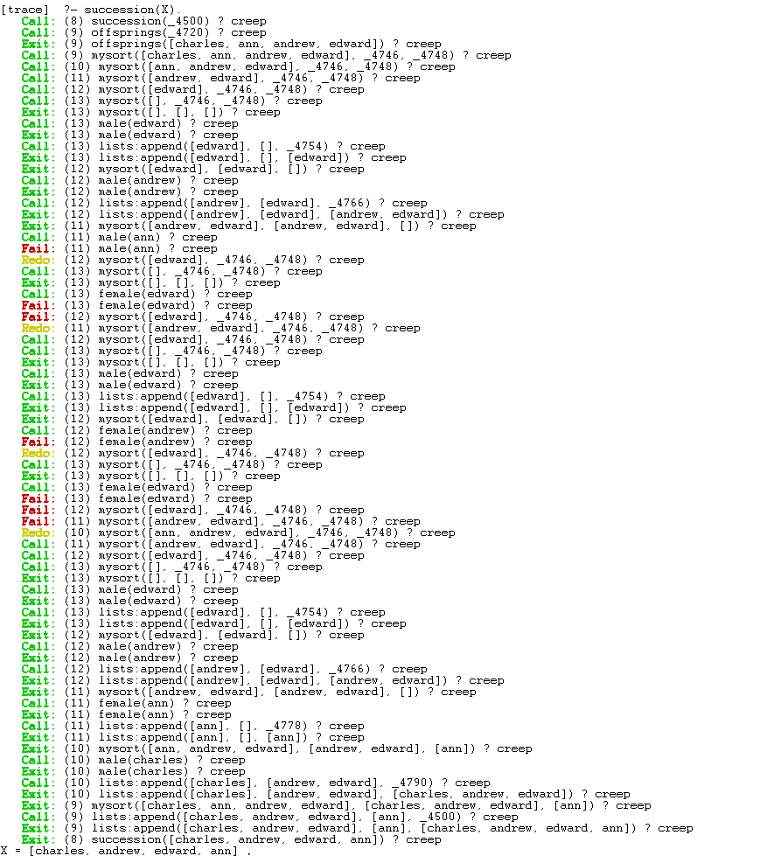

1. new_succession(X) :-

offsprings(X).

